[Skip to main content](http://www.rajalakshmicolleges.org/moodle/mod/quiz/review.php" \l "maincontent)

REC-CIS

GE23131-Programming Using C-2024

|  |  |
| --- | --- |
| **Status** | Finished |
| **Started** | Tuesday, 26 November 2024, 5:33 PM |
| **Completed** | Tuesday, 26 November 2024, 9:20 AM |
| **Duration** | 27 days 8 hours |

Top of Form

Question **1**

Correct

Marked out of 3.00

Flag question

Question text

Write a program that prints a simple chessboard.

Input format:

The first line contains the number of inputs T.

The lines after that contain a different values for size of the chessboard

Output format:

Print a chessboard of dimensions size * size. Print a Print W for white spaces and B for black spaces.

Input:

2

3

5

Output:

WBW

BWB

WBW

WBWBW

BWBWB

WBWBW

BWBWB

WBWBW

Answer:(penalty regime: 0 %)

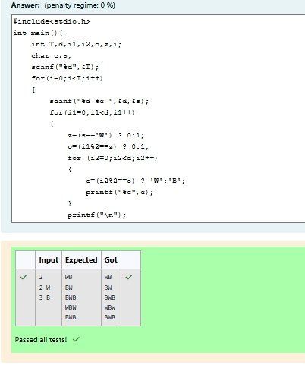

Feedback

|  | **Input** | **Expected** | **Got** |  |
| --- | --- | --- | --- | --- |
|  | 2  3  5 | WBW  BWB  WBW  WBWBW  BWBWB  WBWBW  BWBWB  WBWBW | WBW  BWB  WBW  WBWBW  BWBWB  WBWBW  BWBWB  WBWBW |  |

Passed all tests!

Question **2**

Correct

Marked out of 5.00

Flag question

Question text

Let’s print a chessboard!

Write a program that takes input:

The first line contains T, the number of test cases

Each test case contains an integer N and also the starting character of the chessboard

Output Format

Print the chessboard as per the given examples

Sample Input / Output

Input:

2

2 W

3 B

Output:

WB

BW

BWB

WBW

BWB

Answer:(penalty regime: 0 %)

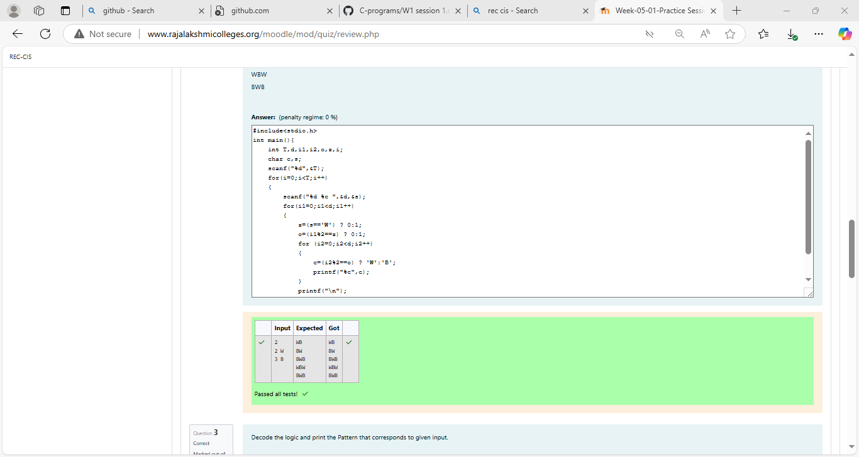

Feedback

|  | **Input** | **Expected** | **Got** |  |
| --- | --- | --- | --- | --- |
|  | 2  2 W  3 B | WB  BW  BWB  WBW  BWB | WB  BW  BWB  WBW  BWB |  |

Passed all tests!

Question **3**

Correct

Marked out of 7.00

Flag question

Question text

Decode the logic and print the Pattern that corresponds to given input.

If N= 3

then pattern will be :

10203010011012

**4050809

****607

If N= 4, then pattern will be:

1020304017018019020

**50607014015016

****809012013

******10011

Constraints

2 <= N <= 100

Input Format

First line contains T, the number of test cases

Each test case contains a single integer N

Output

First line print Case #i where i is the test case number

In the subsequent line, print the pattern

Test Case 1

3

3

4

5

Output

Case #1

10203010011012

**4050809

****607

Case #2

1020304017018019020

**50607014015016

****809012013

******10011

Case #3

102030405026027028029030

**6070809022023024025

****10011012019020021

******13014017018

********15016

Answer:(penalty regime: 0 %)

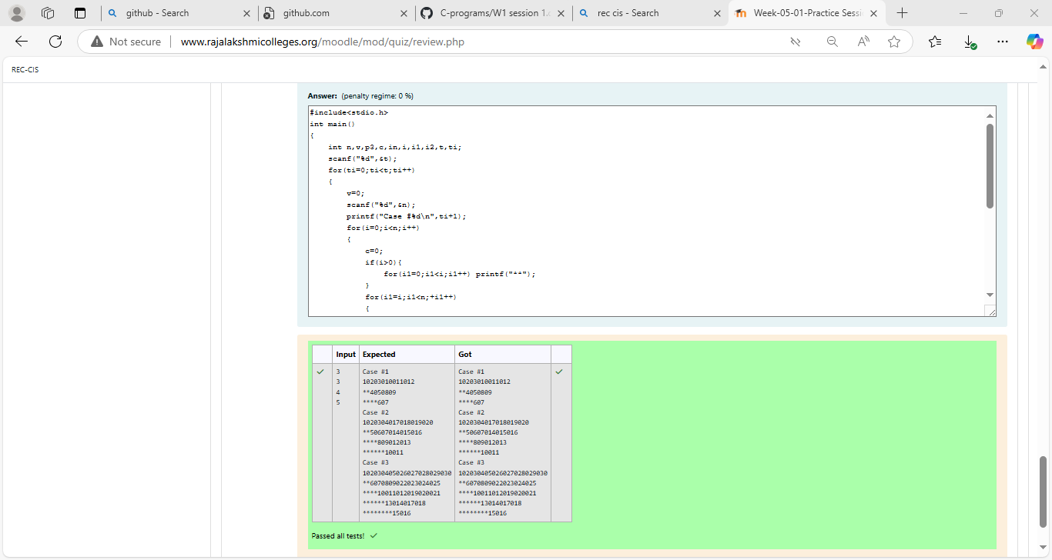

Feedback

|  | **Input** | **Expected** | **Got** |  |
| --- | --- | --- | --- | --- |
|  | 3  3  4  5 | Case #1  10203010011012  **4050809  ****607  Case #2  1020304017018019020  **50607014015016  ****809012013  ******10011  Case #3  102030405026027028029030  **6070809022023024025  ****10011012019020021  ******13014017018  ********15016 | Case #1  10203010011012  **4050809  ****607  Case #2  1020304017018019020  **50607014015016  ****809012013  ******10011  Case #3  102030405026027028029030  **6070809022023024025  ****10011012019020021  ******13014017018  ********15016 |  |

Passed all tests!

Bottom of Form

Blocks

[Skip Quiz navigation](http://www.rajalakshmicolleges.org/moodle/mod/quiz/review.php#sb-1)

Quiz navigation

[Question1This page](http://www.rajalakshmicolleges.org/moodle/mod/quiz/review.php#question-98357-1)[Question2This page](http://www.rajalakshmicolleges.org/moodle/mod/quiz/review.php#question-98357-2)[Question3This page](http://www.rajalakshmicolleges.org/moodle/mod/quiz/review.php#question-98357-3)

[Show one page at a time](http://www.rajalakshmicolleges.org/moodle/mod/quiz/review.php?attempt=98231&cmid=122&showall=0)

Blocks